Chapter 10, Solution 10.

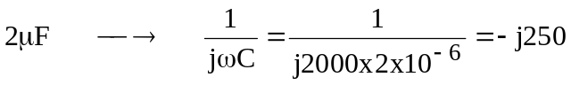
Consider the frequency-domain equivalent circuit below.

V₁ -j250 V₂

36∠0º
2k j100 0.1V₁ 4k

At node 1,

(1)

At node 2,

(2)

Solving (1) and (2) gives

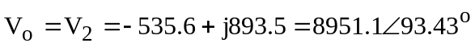

v_{o} (t) = 8.951 sin(2000t +93.43º) kV

